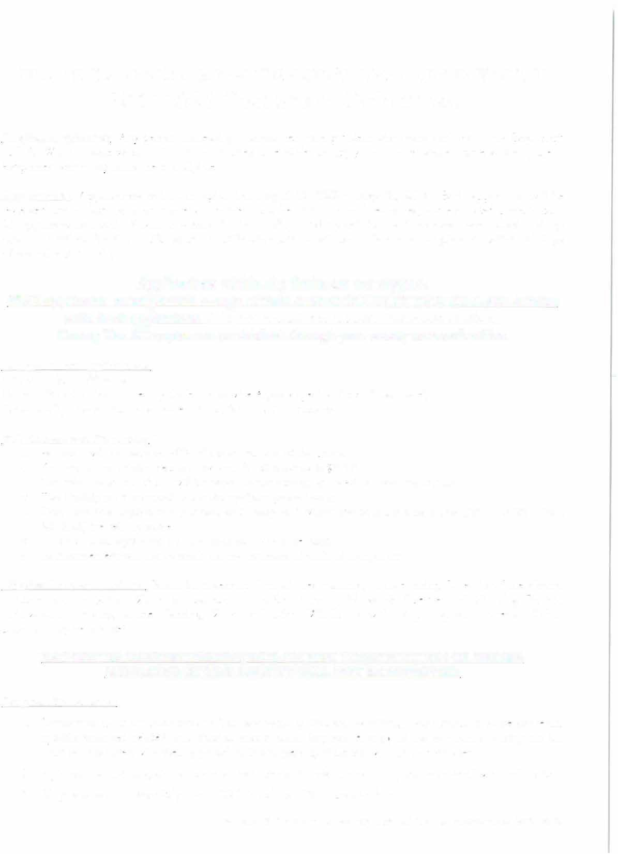
CENTRAL TRI-COUNTY
SOIL & WATER CONSERVATION DISTRICT

2026 SMALL ACREAGE AGRICULTURE GUIDELINES

Eligible Applicants: Any person addressing a natural resource problem who owns land within the Central Tri-County Soil & Water Conservation District boundaries is eligible to apply for a cost-share conservation project. Properties within city limits are not eligible.
Applications: Applications will be accepted beginning October 7, 2026 on a first-come/first-served basis. Each application will be reviewed and ranked based on conservation merit and benefit to natural resources and estimated project costs.

All applications received will be ranked on a first-come/first-served basis. Funding will be made to those who meet ranking criteria, until all funds are allocated. Notification letters will be mailed to all applicants within 10 days of completed ranking.
Applications within city limits are not eligible.
**All applicants must provide a copy of their current COUNTY TAX BILL and submit with their application. (Do not submit the County Valuation Notice).
County Tax Bill copies can be obtained through your county assessor's office.
Categories for applications:
Small Agriculture: l lot – 1000 acres

Reimbursement:
Payments will be made on 85% of the actual cost of the project.
o The maximum reimbursement payment for all projects is $10,000.
o The reimbursement check will be issued to the name(s) as entered on their application.
o The Participant is responsible for the up-front project costs.
o Only practices applied for, planned, and completed within the contract time frame will be reimbursed. (October 7, 2026 - June 30, 2027)
o All original receipts must be submitted for reimbursement.
o Reimbursement will not be made for the purchase of tools or equipment.

Eligible Practices Include: Critical Area Planting, Cross Fencing, Diversion, Irrigation Water Management, Irrigation Pipeline, Livestock Pipeline and Watering Facility, Shade Balls, Range Planting, Watering Facility, Windbreak with Drip Irrigation Systems, Cholla Removal, and Virtual Fencing. (Other practices may be eligible).

Program Procedures:

- Landowners must complete the attached cost share application identifying their natural resource concern, specific practice needed, and detailed conservation impacts.
- A copy of the applicant's county tax bill must be submitted with their application. Incomplete applications will not be processed.
- Applications and program paperwork must be complete with all signatures of applicants listed when submitted.
- All practices must meet Central Tri-County SWCD specifications.
- Any costs incurred before approved or contracts signed prior to October 7, 2026 are not eligible for reimbursement.
- Each approved cost-share Participant will be provided with project specifications, a project plan and estimated cost from the District technician during their initial on-site planning.
- Scheduling on-site planning by District staff will begin after July 1, 2026.
- Project work can begin after the District and the Participant sign the Project Agreement.
- Central Tri-County SWCD is not responsible for arrangements/ quotes/contracts between Participants and contractors.
- Projects rnust be completed by June 30, 2027. Final on-site checkout deadline is Thursday, June 30, 2027.
- No project extensions are allowed. Projects must be completed within the district's fiscal year.
- A Participant may cancel their project and Project Agreement at any time. The Participant must notify Central Tri-County SWCD to ensure cancellation is recorded and filed.
- If a Participant cancels or does not complete their project within the District's fiscal year, the Participant may reapply for cost-share assistance after 5 years. Incomplete or cancelled projects have ranking score implications during reapplication.
- A former cost-share Participant may apply for additional cost-share projects after 3 years from their previous project completion date. Ranking scores are lessened for previous Participants.
- When the practice is 100% completed, contact Central Tri-County SWCD to schedule an on-site inspection of the practice for approval and review the Participant's receipts. District staff will then file the proper forms to reimburse the Participant. Incomplete or unsatisfactory projects are not reimbursable.
- Participants must provide the original expense receipts and attach them to their completed Reimbursement Form at time of the project checkout.
- Only one payment will made with the name(s) of the Participant as listed on the application. The payment will be mailed to the Participant(s) within 30 days after inspection.
- Spot checks of the practice will be performed to ensure compliance.

